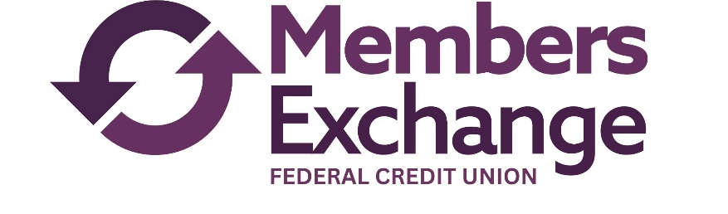
Members Exchange Federal Credit Union
Language Assistance Plan (LAP)
Effective Date: June 3, 2025

1. Policy Statement
Members Exchange Federal Credit Union is committed to ensuring meaningful access to its programs, services, and activities for individuals with limited English proficiency (LEP). Language assistance services will be provided free of charge to LEP individuals in accordance with Title VI of the Civil Rights Act of 1964.

2. Identifying LEP Individuals
Members Exchange Federal Credit Union will identify LEP individuals through the following practices:
- Asking individuals their preferred language at the first point of contact.
- Posting “I Speak” cards or language identification signage in public areas.
- Recording language preference in client records when appropriate.

3. Providing Oral Language Assistance
Free interpreter services will be offered to all LEP individuals. Options include:
- Qualified bilingual staff, where available.
- Contracted professional interpreters.
- Telephone-based interpretation services.
LEP individuals may choose to use a family member or friend as an interpreter only after being offered a free interpreter and declining. This decision will be documented, and Members Exchange Federal Credit Union reserves the right to provide its own interpreter when accuracy, confidentiality, or conflict of interest is a concern. Children will not be used as interpreters.

4. Translating Vital Documents
Members Exchange Federal Credit Union will translate vital documents—such as applications, consent forms, notices of rights, and eligibility criteria—into any non-English language spoken by 5% or 1,000 individuals in the eligible service area, whichever is less.
Other documents may be translated upon request or as needed.

5. Notice to the Public
Notices informing the public of free language assistance services will be:
- Posted in intake and reception areas.
- Included on Members Exchange Federal Credit Union ’s website at mecuanywhere.com
- Shared in outreach materials when feasible.
- Disseminated through community partners and, if appropriate, local media.

6. Staff Training
All staff who interact with the public will receive training on:
- Identifying language assistance needs.
- Accessing interpreter and translation services.
- Documenting interactions with LEP individuals.
Managers will ensure staff are aware of this LAP and trained appropriately.

7. Monitoring and Updating the LAP
Members Exchange Federal Credit Union will review this plan at least annually and update it as needed based on:
- Demographic changes in the service area.
- Feedback from staff and community members.
- Evaluation of language service effectiveness.
- Changes in federal requirements.

Contact for Language Access:
Misty Munn, Senior Vice President
601.923.4329
mmunn@memexcu.com

